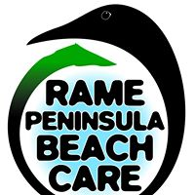
Rame Peninsula Beach Care
Lower Rock House
The Cleave
Kingsand
Cornwall
PL10 1NG

Rame Peninsula Beach Care

Membership Application Form
Name:
Address:
Telephone number/s:
E-mail address:

I support the work and objectives of Rame Peninsula Beach Care and would like to apply to become a member. I enclose a £1 membership fee.

Signature:…………………………………… Date:…………………………

